Database Systems Design Project

Marist Connections

Daniel Cody

Professor Labouseur

18 November 2014

**Table of Contents**

Database Description …………………………………………………… 3

ER Diagram …………………………………………………………….. 4

Forums Table …………………………………………………………… 5

SubForums Table ………………………………………………….…… 6

Date Table ……………………………………………………………… 7

Posts Table ……………………………………………………………... 8

Users Table …………………………………………………………….. 9

Messages Table ………………………………………………………... 11

ItemExchange Table …………………………………………………... 12

Offers Table …………………………………………………………… 13

Views ………………………………………………………………….. 14

Queries ………………………………………………………………… 15

Store Procedures ………………………………………………………. 16

Triggers ……………………………………………………………….. 17

Security ……………………………………………………………….. 18

Known Issues …………………………………………………………. 19

Future Enhancements …………………………………………………. 20

**Database Description:**

My design project is to design a database for a Social Networking Website for Marist College. This website lets users sign up, connect their different social media accounts to their username. Then they are allowed to post on forums to ask about what is happening on their college campus. Users can message each other to meet people and communicate with people that they do not know. Also the users are also allowed to post items to be sold on their campus such as books, laptops, dorm room accessories, electronics, and more.

**ER Diagram**

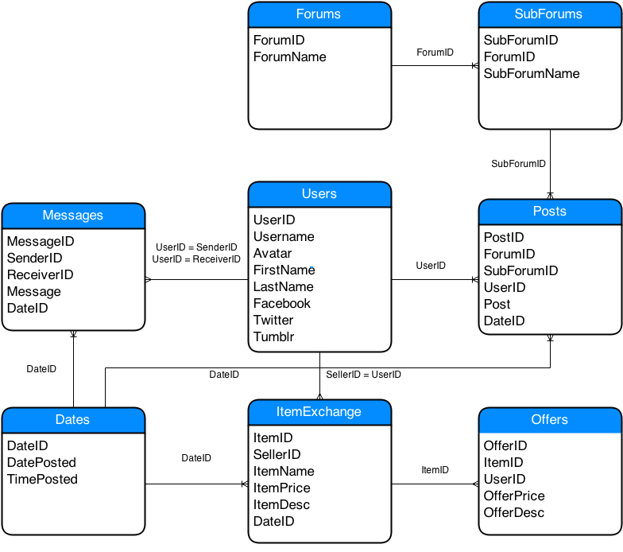

**Forums Table**

**Description:**

This table is needed to keep track of the general forum topics such as classes, teachers, nightlife, intramurals and more.

**Functional Dependency:**

ForumID -> ForumName

**Create Statement:**

CREATE TABLE Forums (

ForumID serial NOT NULL,

ForumName text NOT NULL,

PRIMARY KEY(ForumID)

);

**Example Data:**

|  |  |
| --- | --- |
|  |  |
| ForumID | ForumName |
| 1 | Classes |
| 2 | Teachers |
| 3 | Intramurals |

**SubForums Table**

**Description:**

This table is derived from the forums table, which based on the large forum topic such as teachers; you can select a specific forum on that topic such as Alan Labouseur or Benjamin Carle.

**Functional Dependency:**

SubForumID -> ForumID, SubForumName

**Create Statement:**

CREATE TABLE SubForums (

SubForumID serial NOT NULL,

ForumID integer NOT NULL REFERENCES Forums(ForumID),

SubForumName text NOT NULL,

PRIMARY KEY(SubForumID)

);

**Example Data:**

|  |  |  |
| --- | --- | --- |
| SubFormID | ForumID | SubForumName |
| 1 | 1 | Database Systems |
| 2 | 1 | Operating Systems |
| 3 | 2 | Alan Labouseur |
| 4 | 2 | Benjamin Carle |
| 5 | 3 | Soccer |

**Date Table**

**Description:**

This table keeps track of all the different dates in which things happened by keeping an ID, which relates to a specific date and time

**Functional Dependency:**

DateID -> DatePosted, Time

**Create Statement:**

CREATE TABLE Dates(

DateID serial NOT NULL,

DatePosted date NOT NULL,

Time integer NOT NULL,

PRIMARY KEY(DateID)

);

**Example Data:**

|  |  |  |
| --- | --- | --- |
| Dates Table |  |  |
| DateID | DatePosted | Time |
| 1 | 9/13/14 | 3:07 PM |
| 2 | 9/14/14 | 5:21 PM |
| 3 | 9/14/14 | 11:17 AM |
| 4 | 9/14/14 | 12:30 PM |
| 5 | 9/15/14 | 1:53 PM |
| 6 | 9/20/14 | 3:07 PM |
| 7 | 9/20/14 | 9:42 AM |
| 8 | 9/22/14 | 8:01 AM |
| 9 | 9/25/14 | 9:07 PM |
| 10 | 9/29/14 | 3:21 PM |
| 11 | 9/30/14 | 7:34 AM |
| 12 | 10/1/14 | 2:42 PM |
| 13 | 10/5/14 | 12:51 PM |
| 14 | 10/6/14 | 11:00 AM |

**Posts Table**

**Description:**

This table is used to keep track of the posts that are made on a specific Sub Forum.

**Functional Dependency:**

PostID -> ForumID, SubForumID, UserID, Post, Time

**Create Statement:**

CREATE TABLE Posts (

PostID serial NOT NULL,

ForumID integer NOT NULL REFERENCES Forums(ForumID),

SubForumID integer NOT NULL REFERENCES SubForums(SubForumID),

UserID integer NOT NULL REFERENCES Users(UserID),

Post text NOT NULL,

DateID integer NOT NULL REFERENCES Dates(DateID),

PRIMARY KEY(PostID)

);

**Example Data:**

|  |  |  |  |  |
| --- | --- | --- | --- | --- |
| PostID | SubForumID | ForumID | Post | DateID |
| 1 | 1 | 1 | Great class, learn a ton | 1 |
| 2 | 2 | 1 | Hard but worth the work | 2 |
| 3 | 2 | 1 | Don’t wait till last min for HW | 3 |
| 4 | 3 | 2 | Alan is the man, 007 | 4 |
| 5 | 4 | 2 | Hard, but very rewarding | 7 |
| 6 | 5 | 3 | Anyone want to make a team? | 10 |
| 7 | 4 | 2 | Hard grader | 11 |
| 8 | 5 | 3 | I am down to make a team! | 12 |
| 9 | 1 | 1 | Love the design project | 14 |

**Users Table**

**Description:**

This table is used to keep track of each individual user, their first and last name as well as their social media information so they can link their accounts to their social media accounts.

**Functional Dependency:**

UserID ->Username, Password, Avatar, FirstName, LastName, Facebook, Twitter, Tumblr,

**Create Statement:**

CREATE TABLE Users (

UserID serial NOT NULL,

Username text NOT NULL,

Password text NOT NULL,

Avatar text DEFAULT 'Avatar.png',

FirstName text NOT NULL,

LastName text NOT NULL,

Facebook text DEFAULT 'facebook.com',

Twitter text DEFAULT 'twitter.com',

Tumlbr text DEFAULT 'tumblr.com',

PRIMARY KEY(UserID)

);

**Example Data:**

|  |  |  |  |  |  |  |  |
| --- | --- | --- | --- | --- | --- | --- | --- |
| UserID | Username | | Password | | | | |
| 1 | dcods22 | | $1$O3JMY.Tw$ewfdLnLjQ/ewfweF9.MTp3gHv/ | | | | |
| 2 | btbishop | | $1$O3JMY.Tw$AdLnLjQ/5jXF9.MTp3gHv/ | | | | |
| 3 | bigPhilly | | $1$O3JMY.Tw$AdLewfeLjQ/5jXF9.ewfgHv/ | | | | |
| 4 | bicepsfordays | | $1$O3JMY.Tw$AntyLjQ/5jXF9tyntyp3gHv/ | | | | |
|  |  | |  | | | | |
| FirstName | | LastName | | Facebook | Twitter | Tumblr |
| Dan | | Cody | | Dan Cody | dcods22 | Dan_Cody |
| Brenden | | Bishop | | Bren Bishop | bbishop93 | BT_Bishop |
| Phillip | | Picinic | | Phil Picinic | bigPhil67 | Big_Phil |
| Michael | | Figguerito | | Mike Figs | bigBiceps11 | Mikey_Biceps |

**Messages Table**

**Description:**

This table is used to keep track of the messages sent between users.

**Functional Dependency:**

MessageID -> SenderID, ReceiverID, Message, Time

**Create Statement:**

CREATE TABLE Messages (

MessageID serial NOT NULL,

SenderID integer NOT NULL,

ReceiverID integer NOT NULL,

Message text NOT NULL,

DateID integer NOT NULL REFERENCES Dates(DateID),

PRIMARY KEY(MessageID)

);

**Example Data:**

|  |  |  |  |  |
| --- | --- | --- | --- | --- |
| MessageID | SenderID | ReceiverID | Message | DateID |
| 1 | 1 | 2 | Wanna watch the MNF game? | 5 |
| 2 | 2 | 1 | Yea Ill be right over | 6 |
| 3 | 3 | 1 | Hows AI going? | 8 |
| 4 | 4 | 2 | Want to go to the caf? | 9 |
| 5 | 1 | 3 | Awful I dropped | 13 |

**ItemExchange Table**

**Description:**

This table is used to keep track of the items that are posted in the item exchange to be sold between people on campus.

**Functional Dependency:**

ItemID -> SellerID, ItemName, ItemPrice, ItemDesc, DatePosted

**Create Statement:**

CREATE TABLE ItemExchange (

ItemID serial NOT NULL,

SellerID integer NOT NULL REFERENCES Users(UserID),

ItemName text NOT NULL,

ItemPrice integer NOT NULL,

ItemDesc text NOT NULL,

DateID integer NOT NULL REFERENCES Dates(DateID),

PRIMARY KEY(ItemID)

);

**Example Data:**

|  |  |  |  |  |
| --- | --- | --- | --- | --- |
| ItemID | SellerID | ItemName | ItemPrice | ItemDesc |
| 1 | 1 | Samsung 32'' TV | 200 | Just a year old |
| 2 | 1 | Lazy Boy | 50 | Slight rip in leather |
| 3 | 2 | Database Textbook | 100 | Barley Used, good read |
| 4 | 4 | Dumbells | 20 | Very Heavy |

**Offers Table**

**Description:**

This table is used to keep track of the offers that are posted on a specific Item in the exchange.

**Functional Dependency:**

OfferID -> ItemID, UserID, OfferPrice, OfferDesc

**Create Statement:**

CREATE TABLE Offers (

OfferID serial NOT NULL,

ItemID integer NOT NULL REFERENCES ItemExchange(ItemID),

UserID integer NOT NULL REFERENCES Users(UserID),

OfferPrice integer NOT NULL,

OfferDesc text NOT NULL,

PRIMARY KEY(OfferID)

);

**Example Data:**

|  |  |  |  |  |
| --- | --- | --- | --- | --- |
| OfferID | ItemID | UserID | OfferPrice | OfferDesc |
| 1 | 1 | 3 | 125 | Is it 1080p |
| 2 | 1 | 2 | 150 | Any Scratches? |
| 3 | 4 | 1 | 15 | How Heavy? |
|  |  |  |  |  |

**Views**

**Description:**

Views are extremely useful to display certain pieces of the data in one format, where it is not stored in that way in the table. It is very helpful when trying to set permissions or only allowing certain people to have access to certain data. This could be very useful in a case of a school, where all the students information should not be available to everyone, but might be stored all in one table. Information such as social security numbers, and addresses are not important to teachers, but my contact info might be.

**Example:**

CREATE OR REPLACE VIEW PostInfo

AS

SELECT f.ForumName, s.SubForumName, u.UserName, p.Post, p.DatePosted

FROM Users u

INNER JOIN Posts p ON p.UserID = u.UserID

INNER JOIN Subforums s ON p.SubForumID = s.SubForumID

INNER JOIN Forums F ON s.ForumID = f.ForumID;

**Queries**

**Description:**

Queries are used to change, update, or select information from a database. These statements can be written to select data from multiple tables, and also can have different statements attached to it, which will select different data. Set operations, joins, keywords, and mathematic functions can be applied to each query, which will return a special set of data.

**Examples:**

SELECT f.forumName, s.subForumName FROM

subforums s INNER JOIN forums f ON f.forumID = s.forumID;

|  |  |
| --- | --- |
| ForumName | SubForumName |
| Classes | Database Systems |
| Classes | Operating Systems |
| Teachers | Alan Labouseur |
| Teachers | Benjamin Carle |
| Intramurals | Soccer |

SELECT * FROM Posts

WHERE subForumID IN

(SELECT subForumID FROM SubForums

WHERE SubForumName = 'Alan Labouseur');

|  |  |  |  |  |
| --- | --- | --- | --- | --- |
| PostID | SubForumID | ForumID | Post | DateID |
| 4 | 3 | 2 | Alan is the man, 007 | 4 |

**Store Procedures**

**Description:**

A store procedure is a compilation of SQL statements that are put together into one function to do a specific task.

**Example:**

CREATE OR REPLACE FUNCTION MostUsedForum() RETURNS

TABLE (forumName text, count integer) as $$

SELECT forumID, max(num)

FROM

(SELECT forumID, COUNT(forumID) as num

FROM subForums GROUP BY forumID)

subForums

GROUP BY forumID

ORDER BY MAX DESC

LIMIT 1;

$$ language 'sql' $$

**Triggers**

**Description:**

A trigger can be used to do an function upon another event on a table.

**Example:**

CREATE TRIGGER UpdateOnOffer ON offers FOR INSERT AS

BEGIN

SELECT @itemID =

(SELECT itemID FROM offers

ORDER BY itemID DESC LIMIT 1);

SELECT @buyerID =

(SELECT userID FROM offers

ORDER BY itemID DESC LIMIT 1);

SELECT @sellerID =

(SELECT sellerID FROM ItemExchange

WHERE itemID = @itemID);

SELECT @dateNum =

(SELECT dateID FROM offers

ORDER BY itemID DESC LIMIT 1);

INSERT INTO messages

(SenderID, ReceiverID, Message, DateID)

VALUES @buyerID, @sellerID, "You Received an offer on your item", @dateNum;

END;

**Security**

There is a decent amount of security already placed on this database. The relationships between tables are enforced by the create statements. This helps enforce insert, update and delete anomalies.

In addition the passwords in the Users table are not stored in plain text they are encrypted with an MD5 crypt hash. Storing passwords in plain text can create major issues if your database is ever breached, which is clearly an issue

Also roles can be created that allow only certain users to do certain things, such as a campus representative can only edit the content on the forums.

**Example:**

CREATE ROLE db_admin

GRANT SELECT, INSERT, DELETE

ON Forums, SubForums, Posts, Users, Messages, ItemExchange, Offers, Dates

TO db_admin;

CREATE ROLE campus_rep

GRANT SELECT, INSERT, DELETE

ON Forums, SubForums, Posts

TO campus_rep;

**Known Issues**

A known issue to this point with the database is, the handling of group messages since there only exists the ability to have a direct message to a user since there is only a sender and a receiver of a message

Another known issue with the database is the ability to link more social media accounts, such as Google+ or Foursquare. The database currently is only setup to have a link to your Facebook, Twitter, and Tumblr accounts.

**Future Enhancements**

Some future enhancements to the website could be to include more of a specific teacher rating system instead of a forum for it. This would entail having a teacher’s table, which could also track the classes they teach. Then the users could rate the specific teachers as well as the classes they took.

Another future enhancement could be to also include a more specific Item Exchange to the website, where the items could be sorted into types such as books, furniture, electronics and more. This would add a table for the item type to the database, which would make the website searchable by each category.